Barley Genetics Newsletter

Volume 45 - 2015

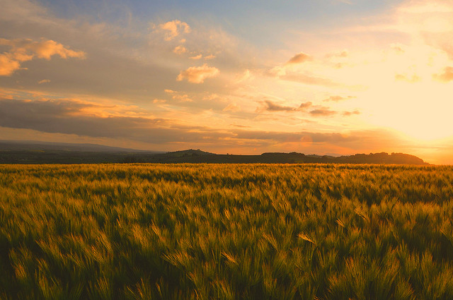

Editorial Committee
P. Bregitzer - U. Lundqvist - Taner Sen

<<Table of Contents>>
<<Information about the Barley Genetics Newsletter>>

The Barley Genetics Newsletter is published electronically at http://wheat.pw.usda/gov/ggpages/bgn

The Barley Genetics Newsletter (BGN) was first published in 1971, and in the years since then has served to disseminate to the barley community announcements, memoria, informal research reports, and detailed descriptions of barley genetic stocks.

In recent years, new forms of rapid communication of ideas and data, principally on-line, have reduced the demand for many aspects of BGN, and the newsletter in its current form has become of limited use to the barley genetics community. At the 12th International Barley Genetics Symposium, held in Minneapolis, Minnesota, USA June 26-30, 2016, the fate of BGN was discussed. It was decided to discontinue the coordinators reports, but that continuing with certain aspects of BGN, and adding new aspects that would foster informal communication, was desirable. There was no significant support for informal research reports, a fact that is reflected on the near-absence of submissions for the last few years. Those with interest in re-developing BGN to enable it to once again to serve the barley genetics community were asked to submit ideas and encouragement to the technical editor, Phil Bregitzer. The number of people who responded to this call: one.

Therefore, volume 45 will be the last of the traditional, yearly "paper" volumes. GrainGenes will continue to host past issues of BGN in electronic format, and will serve as a platform for disseminating announcements, memoria, and significant compilations of data of interest to the community (for instance, additional genetic stock descriptions). Such contributions can be handled on a case-by-case basis by contacting Phil Bregitzer (phil.bregitzer @ars.usda.gov). However, there are no plans for coordinator's reports and informal research reports to be published.

This is the situation as of August, 2016. However, beyond hosting past content and occasional new content, GrainGenes is capable and enthusiastic about hosting additional content and exploring new ways of presenting and fostering discussions and results among researchers and stakeholders within the barley community. Thus, BGN can be reborn in a new form, as long as there is interest within the community.

Acknowledgements
BGN has been made possible by the contributors of research reports, the diligence of the many coordinators, and by the special efforts of leaders in the barley genetics community. Of special note, the compilation of the detailed and extensive new and updated barley genetic stock descriptions published in the last several issues of BGN has been made possible by the time and expertise of Jerry Franckowiak and Udda Lundqvist. Special thanks to the USDA-ARS GrainGenes team.

