Barley Genetics Newsletter 36:28-29 (2006)

Description and technological characteristic of
the new winter two-rowed barley cultivar Caskadior 3

J. Stoinova,¹ K. Tsvetkov² and S. Tsvetkov²
¹ D. Kostov Institute of Genetics, Bulgarian Academy of Sciences, 1113 Sofia
² Dobrudja Agricultural Institute, 9520 General Toshevo

Professor S. Tsvetkov and team, working at the Dobruja Agricultural Institute released cultivar Caskadior 3. The new winter barley cultivar formed compact crops with good stability to lodging, grain falling out and spike brittleness. It is presented in Fig.1. Caskadior 3 is usually sowed in autumn, but under extremely conditions the plants are successfully grown and in early spring sowing.

The plants were inoculated with spore suspension of leaf and stem rusts and powdery mildew and showed high resistance to those diseases. The cultivar possesses also high drought resistance. During 2001 under the conditions of extremely high soil dryness in the area of Dobrudja Agricultural Institute is yielded 550 kg/dca average versus 240 kg/dca for wheat. Because of these traits Caskadior 3 is suitable for growing in the whole country.

The data from the State Variety Testing manifest that Caskadior 3 produced higher yield than the standard cultivar Obzor – 14.8%( 95 kg/dca field trial). Its productive yield potentiality in normal years is over 850 kg/dca (the field trial). The precondition for the high yield obtained is also the meiotic stability of cultivar Caskadior3. In telophase II only 1.33% of the analysed over 300 tetrads had micronuclei. On the other hand Maich and Ordonez (2003) considered that systematical plant breeding program directed to increase grain yield simultaneously improved the meiotic performance of hexaploid triticale.

Caskadior 3 formed very large uniform (96.4%) kernels with 1000 kernel weight of 55 grams. Because of that it may be possible with only one cleaning of the raw material to be given to the breweries. The protein content is 9.7% versus 10.4% for the standard cultivar and which guaranteed high quality of the beer obtained. The cultivar Caskadior 3 fulfills all the 15 criteria of European Convention for beer industry (Holland) and possess high quantity of the extract in the malt – over 81%. Caskadior 3 is the basic material for producing beer “Zagorka”.

Seed producing is high paying, because the cultivar is close pollinated and the foreign pollination is not possible.

Reference
Georgieva. V. 2002. My farma. N 568, p.5.

Maich, R. and Ordonez, A. 2003. Improved meiotic index in hexaploid triticale (x Triticosecale Wittmack).Cytologia, 68, 303 – 306.

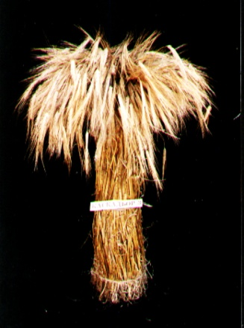

Fig. 1. Plants bundle of cultivar Caskadior 3

