Cytological investigation of winter two-rowed barley cv. Castor, the first Bulgarian cultivar of high cold resistance

J. Stoinova¹, K. Tsvetkov² and S. Tsvetkov²
¹D. Kostov Institute of Genetics, Bulgarian Academy of Sciences, 1113 Sofia
²Dobrudja Agricultural Institute, 9520 General Toshevo

Absract
The cytological investigation comprises diakinesis, metaphase I, anaphase I and telophase II. In diakinesis 14.3% of the cells examined contain 6 closed bivalents and 1 open bivalent. The latter forms a rod bivalent in metaphase I. In anaphase there are laggard chromosomes in 5.8% of the cells while 7.0% of the cells contain anaphase bridges. There are not disturbances in telophase II and the meiotic stability is a prerequisite for high yield of about 800-850 kg/dca (a field trial).

Key words: barley, meiosis, open bivalent, anaphase bridge

Two-rowed barley cultivars occupying arable area in Bulgaria, belong to the winter-spring cereals which are highly productive and of low cold resistance. In severe winters with poor snow most barley plants die resulting in large economical loses. In 1993-2003 Prof. S. Tsvetkov working at the Dobrudja Agricultural Institute released the first Bulgarian two-rowed barley cultivar Castor possessing exclusively high cold resistance along with good productivity. The cytological analysis of the cultivar and the relationship between meiosis and grain yield were the subject of this study.

The standard aceto-carmine method was used to examine 35 cells for diakinesis, 145 cells for metaphase I, 170 cells for anaphase I and 200 tetrads for telophase II. Table 1 provides data indicating that in diakinesis over 85% of the cells contain 7 closed bivalents while 14.3% of the cells contain one open bivalent, associated with nucleolus. The phenomenon has been observed in other investigations (Stoinova, 1994; Stoinova and Tsvetkov, 2004).

The data concerning metaphase I indicate that almost 80% of the cells contain 7 closed bivalents/cell. The open bivalent in diakinesis forms a rod bivalent at metaphase I in 17.3% of the cells (Fig. 1a). Five closed and 2 rod bivalents were scored in four cells, while in one cell four closed and 3 rod bivalents were scored. Neither univalents nor multivalent associations were observed.

There were laggard chromosomes and bridges in anaphase cells (Fig. 1b and 1c). The laggards form genetically inactive micronuclei at telophase II only in single tetrads. At that phase cell partitions are properly situated, except for one preparation where 2 triads were observed. The presence of anaphase bridges was more interesting as their emergence is associated with paracentric inversion in heterozygous state. Synapsis between inverted and non-inverted chromosomes is accompanied by loop formation in pachytene. In the case of crossing over in that inversion loop anaphase bridges and fragments may be formed.

Anaphase bridges may result from gamma irradiation with 5 to 50 kR of barley chromosomes, the bridge frequency increasing with irradiation dose (Chandra and Makde, 1982). The barley ring chromosomes may also lead to anaphase bridges in about 10% of the assayed cells (Singh and Tsuchiya, 1981). Bridge configurations have been found in tumor cells as well (Hoffelder, et al., 2004).

Disturbances at anaphase I in plant cells depend on environmental temperature. In two bean cultivars the disturbances have been found to vary from 34.5% to 58% at 22-26° C and decrease to 22-31% at 15-19° C (Konstantinov, 1971). Sakata et al. (2000) have shown that in barley the early stage until meiosis of PMCs is the most sensitive to high temperature stress. The stress may cause emergence of abnormal and irregularly shaped pollen grains at the heading stage. In cultivar Castor the disturbances at anaphase I are most probably due to high temperature during spike fixation, since chromosome reconstruction of inversion type proceed with very low frequency under normal environment, in the absence of chemical or physical mutagens and no ring chromosomes have been observed. The lack of disturbances at final meiosis phase is a prerequisite for normal pollen production and pollination as well as for high grain yield (up to 800-850 kg/dca a field trial).

The data from this cytological investigation suggest that meiosis in cultivar Castor proceeds without formation of univalents and multivalent associations at metaphase I with low percentage of laggard chromosomes and anaphase bridges while micronuclei may be present only in a single tetrads.

Table 1. Analysis of meiosis in barley Castor
Diakinesis |  |  |  | Metaphase I |  |  |  | Anaphase I
Cells with  7closed bivalents |  | Cells with  6 closed +  1 open bivalent |  | Cells with  7 closed bivalents |  | Cells with  6 closed + 1 rod bivalent |  | Normal cells |  | Cells with  laggard chromo-  somes |  | Cells with bridge configur-  ation
n | % | n | % | n | % | n | % | n | % | n | % | n | %
30 | 85.7 | 5 | 14.3 | 119 | 82.7 | 26 | 17.3 | 148 | 87.2 | 10 | 5.8 | 12 | 7.0

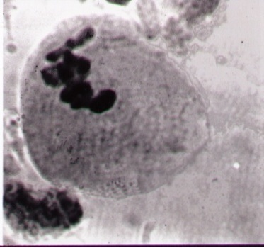

Fig. 1a. Metaphase I with rod bivalent

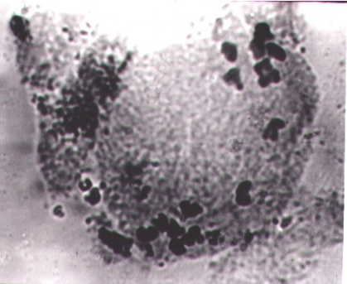

Fig.1b. Anaphase I with laggard chromosome

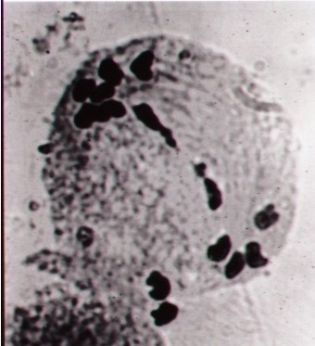

Fig.1c. Anaphase I with bridge configuration

References:
Chandra, A. and Makde, K. H. 1982. The rupture of radiation including bridges in barley. BGN 12: 11-13.
Hoffelder, D. R., Luo, L., Burke, N .A., Watkins, S. C., Gollin, S. M. and Sanders, W. S. 2004. Resolution of anaphase bridges in cancer cells. Chromosoma 112:389-397.
Konstantinov, A. V. 1971. Meiosis. Minsk, 18-19.
Sakata, T., Takahashi, H., Nishiyama, I. and Higashitani, A. 2000. Effects of high temperature on the development of pollen mother cells and microspores in barley, Hordeum vulgare L. J of Plant Res. 113:395-402.
Singh, R. J. and Tsuchiya. 1981. Ring chromosomes in barley (Hordeum vulgare L.). Chromosoma 82:133-141.
Stoinova, J. 1994. Characteristics of meiosis in some winter barley varieties. Cytologia 59:423-426.
Stoinova J. and Tsvetkov, S. 2004. Meiosis and productivity relationships in Bulgarian winter barley lines. BGN 34:5-9.

