Expression of a P450 gene in barley (Hordeum vulgare)

Linh Nguyen and Robert J. Henry
Molecular Plant Breeding Cooperative Research Centre,
Centre for Plant Conservation Genetics, Southern Cross University, PO Box 157, Lismore NSW 2480, Australia. lnguye10@scu.edu.au

The sequence reported here was submitted to GenBank (Accession number DQ838490)

Abstract
A new member of the P450 gene family was identified in barley. The P450 gene was a member of the subfamily CYP72A. Northern analysis revealed that various CYP72A39 transcripts were found in four barley cultivars at a very early vegetative stage but no expression was detected at the reproduction stage. This suggested that this P450 gene may be involved in seedling development in barley. Comparison of expression profiles of this gene and “digital expression” databases confirmed that this gene was homologous to several cereal EST clones with tissue-specific transcripts responding to various environmental stimuli. Among these, many transcripts in barley were obtained from stressed tissues at the vegetative stage, and two transcripts in wheat were expressed after being challenged by barley powdery mildew pathogen (Bumeria graminis f. sp. hordei). This suggested that the CYP72A39 gene may play a role in defence in the barley seedling.

Introduction
Plant P450s belong to the cytochrome group of membrane-bound enzymes, that are usually found in plant endoplasmic reticulum (Halkier, 1996). Among 6008 P450 genes reported in all organisms including human, one third of them have been reported in plant species. In plants, P450s play a central role in numerous biosynthetic pathways such as production of second metabolites (phenylpropanoids, alkaloids, lipids, sterols, flavonoids and cyanogenic glycosides). In addition, plant P450s have a significant response to stresses (Whitbred and Schuler, 2000) and disease (Smigocki and Wilson, 2004; Takemoto et al., 1999). P450 enzymes that are encoded by P450 genes are important components of the defense mechanism of plants through their enzymatic reactions in various biosynthesis pathways. Depending on the type of stimuli, specific enzymes are produced under stress conditions. Many reports (Bolwell et al., 1994; Halkier, 1996; Mizutani et al., 1998; Persans et al., 2001; Schuler and Wreck-Reichhart, 2003; Toguri et al., 1993c) have emphasized the affects of environmental factors such as stresses (salinity, low temperature, pathogen elicitation) as well as developmental factors (plant age, tissue specific) on the expression pattern of plant P450. Here we report the identification and analysis of expression patterns of a new P450 gene in barley.

Materials and methods
Randomly selected clones (512) from a cDNA library of four day old seedling (cv Alexis) were sequenced. Details of the cDNA library construction were previously described by Holton and co-workers (2002). A clone (5E2) was identified showing 72% homology to a P450 (CYP72A21) in rice.

This 1817bp full length sequence, consisting of 1578 nucleotide ORF, 189 nucleotides at the 3' UTR and 50 nucleotides in the promoter region, encoded a 526 amino acid polypeptide with molecular mass of 59.57 kDa and isoelectric point of 8.59. Coding sequence was searched against the P450 database from David Nelson's home page (http://drnelson.utmem.edu/CytochromeP450.html) using BLASTP. P450 motifs and domains in the sequence were detected manually.

Four parental barley lines (Chebec, Harrington, Alexis and Sloop) which have been used in many breeding programs were selected. Two growth conditions, indoor and outdoor, were applied to each cultivar. Observation and sample collection were based on the Zadok score, a measurement of plant growth stage. For each cultivar, samples were collected at different development stages, ranging from young seedling to post-anthesis (Table 1). For all four cultivars, at vegetative stage, both roots and shoots were collected for 4 day and 1 week old seedling samples, and only shoot samples for 2 week old seedling (Parts A, B, C of Figures 1 and 2). At the floral stage, only inflorescence parts were sampled for two cultivars, Chebec and Harrington. Flowering was checked daily and the first appearance of the flag leaf, indicating that the plant was already in its floral stage, was marked. The floral stage (Parts C, D of Figures 1 and 2) was divided into four sub-stages: stage 1 was when the flag leaf was first seen, stage two was when the first awn appeared and stage three was recorded if the first spikelet was seen. These three stages occurred before plants pollinated. When pollination occurred, individual seeds that were pollinated on that day were marked. Two weeks later, these marked seeds were harvested and classified as at sub-stage four.

Total RNA was extracted from the tissues indicated in Table 1 using either RNeasy Plant Mini kit (Qiagen) or CTAB method (Chang et al., 1993). Probes were generated by using DIG-PCR probe synthesis kit (Roche). Membrane transfer, blot hybridisation and detection were carried out according to the manufacturer’s protocol (Roche, 2000). Barley Ubiquitin was used as house keeping gene. RNA extracted from mix-tissues of shoot and root (4 day seedling) was used as positive control. Primer sequences and PCR compositions to generate labelled probes were listed in Tables 2 and 3.

The temperature cycling condition for both probes were very similar. They were 96⁰C for 2 min; followed by 25 cycles of 96⁰C for 1min, 45⁰C for 45s, 72⁰C for 2min, and a final extension at 72⁰C for 10min. The only exception was that the duration of extension at 72⁰C was 1min shorter for the whole 25 cycles when the Ubiquitin primer was used.

Results and discussion
Sequence structure of CYP72A39
Results of a BLAST search of CYP72A39 sequence against the Nelson's P450 database (http://132.192.64.52/p450.html) showed 72% and 68% identity to CYP72A21 and CYP72A33 in rice respectively. This indicated that this new barley gene belong to the CYP72A subfamily and was assigned as CYP72A39.
Several highly conserved regions which are consider as a benchmark of P450s (Fig 3) are found in the gene structure of the new sequence such as:
- The membrane anchor (MVLLGVLASPTPATVLWTLLGLALL) is situated in the first 25 amino acids from the N terminal,
- The C-helix motif (WVKHR) is located from residue 157 to161,
- The I-helix motif (AGSET) required for oxygen binding, is located from residue 335 to 339,
- The K-helix motif (EVLR) is located from residue 391 to 394,
- The P450 signature PERF (also called domain C ) is located from residue 446 to 449,
- The heme binding region PFGWGPRICIG (also called domain D) is located from residue 465 to 475 including the Cystein residue in position 473.
However, the proline rich motif (PPGP) which is usually located between the C-helix and the membrane anchor, was not detectable in the barley CYP72A39 sequence. Similarity, the absence of a proline rich motif in the protein structure of CYP72A1 (accession L10081) was reported in Catharanthus roseus (Irmler et al., 2000).

Gene expression patterns of CYP72A39 by Northern blot analysis
At the vegetative phase, under the same indoor condition; the CYP72A39 gene was expressed differently in all four cultivars. Overall, the CYP72A39 transcript was found in root of 1 week old seedling of all four cultivars (Figures 4, 5, 6). In cultivar Chebec, the gene was expressed only in the root of 1 week old seedling (Figure 4). No transcript was found in shoot at any stage of the vegetative phase of this cultivar. In contrast, in cultivar Alexis, bands were found only in root at 4 day and in 1 week old seedlings (Figure 6). Interestingly, the transcript of the candidate gene hybridised strongly to RNA extracted from mixed tissues (root and shoot at 4 day old seedling) of Alexis that were used as positive probe control in all blots, but there was no evidence of this candidate gene’s transcriptions found in any shoot tissue of this cultivar. Furthermore, as shown in Figures 5 and 6, CYP72A39 was expressed in the shoots and roots of both Sloop and Harrington. At the floral stage, no hybridised bands were detected in any reproductive tissues of any cultivar, under both growth conditions, indoor and outdoor (Figures 4, 5, 6). The house keeping gene, Ubiquitin, was expressed in all tissues of the four cultivars at all developmental stages as expected.

Comparative analysis of gene expression of CYP72A39 and sequences from “electronic expression” databases
The gene expression patterns of CYP72A39 were compared to “electronic expression” data from plant species by homology search. BLAST results indicated that the CYP72A39 matched to numerous ESTs derived from several cDNA libraries (Table 4). However, only a fraction of entries (11 out of 171) are listed here.

Results of the Northern blot experiment showed that transcripts of CYP72A39 were specifically found only in the vegetative tissues of the four cultivars. This study also demonstrated that, in the two cultivars Chebec and Harrington, there was no evidence of CYP72A39 transcripts in any reproductive tissues, either from the growth cabinet or field grown barley. Further more, the blast search against Plant Genome database (Plant GDB) showed that CYP72A39 was highly homolog to EST sequences isolated at seedling stages. These factors suggest that this gene may play a role in seedling development of barley.
In most cases, the CYP72A39 showed significant homology to sequences whose transcripts were induced in vegetative tissues. Blast searches against the Plant GDB server showed several hits to the monocot EST sequences that appeared under stressed or pathogenic challenging. To get more specific sequence homology to each species, blast searches against individual EST database was performed. Results from the searches against the barley EST database showed that the CYP72A39 had 100% identity (over 812/812 nucleotides) at both coding and the 3-UTR region with the barley contig20974 obtained from cold stressed shoots. In the coding region, the three motifs, K helix, C domain and D domain containing the Heme region that essential to a P450 gene, were identical to those found in the CYP72A39 sequence.

Results from the searches against the wheat EST database indicated that the CYP72A39 was strongly homologised to five wheat ESTs from the same cultivar, Fidel. These five wheat ESTs were listed as pathogenic inducible genes. Of these, two EST sequences AJ888598 and AJ890237 showed significant identity (93% over 594/638 and 627/674 nucleotides respectively) to the CYP72A39. Sequence comparison between these two and the CYP72A39 showed that they shared a 168 identical amino acid sequence included the stop codon (ATG). Similar to the barley contig20974 sequence, these two wheat ESTs also contained the three motifs (K helix, C and D domains) identical to those found in the CYP72A39 sequence (Figure7). Ten amino acid substitutions were found between CYP72A39 and the two wheat ESTs. Attention was focused on the AJ888598 sequence, the 3’UTR of which matched to that of the CYP72A39 sequence (data not shown). However at present, information about the wheat EST (AJ888598) was very limited. Overall significant sequence identity at both coding, particularly at the three important motifs, and non-coding regions between the CYP72A39 and several monocot ESTs suggested that the CYP72A39 gene appears to be a good candidate for stress and disease resistant study.

Conclusion
Various expression patterns of CYP72A39 genes were found in four barley cultivars by Northern analysis. These patterns detected in vegetative but not in any reproductive tissues suggested that this gene may be involved in seedling development of barley. In addition, significant homology between this gene and cereal EST samples expressed under stresses and particularly pathogen challenges leads to a speculation that functionally this barley gene is likely to be involved in defence in barley.

Acknowledgments
The authors wish to thank Dr David Nelson for assigning the gene, Dr Agnelo Furtado for technical advice on the hybridisation blot, Dr Timothy Holton for constructing the cDNA library, Toni Spark (Hermitage Research Station) and Dr David Moody (VIDA) for providing the barley seeds. This study was funded by Molecular Plant Breeding CRC.

References
Bolwell, G.P., K. Bozak, and A. Zimmerlin. 1994. Plant cytochrome P450. Phytochemistry. 37:1491-1506.
Chang, S., J. Puryear, and J. Cairney. 1993. A simple and efficient method for isolating RNA from pine trees. Plant Mol Biol Reporter. 11:113-116.
Halkier, B.A. 1996. Catalytic reactivities and structure/function relationships of cytochrome P450 enzymes. Phytochemistry. 43:1-21.
Holton, T.A., J.T. Christopher, L. McClure, N. Harker, and R.J. Henry. 2002. Identification and mapping of polymorphic SSR markers from expressed gene sequence of barley and wheat. Molecular Breeding. 9:63-71.
Irmler, S., G. Schroder, B. St-Pierre, N.P. Crouch, M. Hotze, J. Schmidt, D. Strack, U. Matern, and J. Schroder. 2000. Indole alkaloid biosynthesis in Catharanthus roseus: new enzyme activities and identification of cytochrome P450 CYP72A1 as secologanin synthase. Plant Journal. 24:797-804.
Mizutani, M., E. Ward, and D. Ohta. 1998. Cytochrome P450 superfamily in Arabidopsis thaliana - isolation of cDNAs, differential expression, and RFLP mapping of multiple cytochromes P450. Plant Molecular Biology. 37:39-52.
Persans, M.W., J. Wang, and M.A. Schuler. 2001. Characterization of maize cytochrome P450 monooxygenases induced in response to safeners and bacterial pathogens. Plant Physiol. 125:1126-1138.
Roche. 2000. DIG application manual for filter hybridisation. Roche Diagnostics GmbH, Mannheim/Germany. 225 pp.
Schuler, M.A., and D. Wreck-Reichhart. 2003. Functional genomics of P450s. Ann. Rev. Plant Biology. 54:629-657.
Smigocki, C.A., and D. Wilson. 2004. Pest and disease resistance enhanced by heterologous suppression of a Nicotiana plumbaginifolia cytochrome P450 gene. Biotechnology Letters. 26:1809 - 1814.
Takemoto, D., M. Hayashi, N. Doke, M. Nishimura, and K. Kawakita. 1999. Molecular cloning of a defense-response-related cytochrome P450 gene from tobacco. Plant Cell Physiol. 40:1232-1242.
Toguri, T., N. Umemoto, O. Kobayashi, and T. Ohtani. 1993c. Activation of anthocyanin synthesis genes by white light in eggplant hypocotyl tissues, and identification of an inducible P-450 cDNA. Plant Mol Biol. 23:933-946.
Whitbred, J.M., and M.A. Schuler. 2000. Molecular characterization of CYP73A9 and CYP82A1 P450 genes involved in plant defense in pea. Plant Physiol. 124:47-58.

Table 1. Developmental stages, type of collected tissues and growth conditions of barley materials used in the gene expression experiment.
Developmental stage | Morphological appearance | Type of tissue collected | Growth conditionª | Cultivar^{b}
Vegetative stage | Four day old seedling | Shoot, Root | I | C, H, A, S
Vegetative stage | One week old seedling | Shoot, Root | I | C, H, A, S
Vegetative stage | Two week old seedling | Shoot | I | C, H, A, S
Floral stage | Appearance of flag leaf | Head | I/O | C, H
Floral stage | Appearance of first awn | Head | I/O | C, H
Floral stage | Appearance of first spikelet | Head | I/O | C, H
Floral stage | Two weeks after pollination | Individual seed | I/O | C, H
ªI: Indoor; O: Out door;
^{b}C: Chebec, H: Harrington A: Alexis, S: Sloop

Table 2. Primer sequences
Primer ID | Primer sequence (5'-3') | Probe length (bp)
CYP72A39 forward | TCAAGCACCGGAGGATCCTCA | 1023
CYP72A39 reverse | CAAGGTCGAATTCGAAGCGTTGA | 1023
Ubiquitin forward | CGACAACGTCAAGGCGAAGAT | 314
Ubiquitin reverse | CCAAAGCCACGGCACAAGTT | 314

Table 3. PCR components of labelled and unlabelled samples
 | For CYP72A39 probe |  | For house keeping gene probe
 | Labelled fragment | Unlabelled fragment | Labelled fragment | Unlabelled fragment
10x PCR buffer (1.5mM MgCl2, Roche) | 2μl | 2μl | 2μl | 2μl
Taq Polymerase (5 units, Roche) | 0.4μl | 0.4μl | 0.4μl | 0.4μl
10mM dNTP's (Promega) | _ | 0.4μl | _ | 0.4μl
DMSO | 1μl | 1μl | _ | _
50% glycerol | 1.2μl | 1.2μl | _ | _
PCR DIG mix (10x concentration, Roche) | 2μl | _ | 2μl | _
Primer forward (10μM) | 3μl | 3μl | 3μl | 3μl
Primer reverse (10μM) | 3μl | 3μl | 3μl | 3μl
Plasmid DNA | 10ng | 10ng | 100pg | 100pg
And MiliQ water was added to a total volume | 20μl | 20μl | 20μl | 20μl

Table 4. Representative sequences that homolog to CYP72A39
Accession | Species | Cultivar | Expressed tissue | Description of treatment and sample source (if known) | Nucleotide identity % | E value
Contig 20974* | Barley | Morex | 5 day old shoot seedling | Cold stress (EST and Chip) | 100 (812/812) | 00.0
BF623161 | Barley | Morex | 5 day old shoot seedling | Cold stress (EST and Chip) | 98 (581/591) | 0.00
AJ888598 | Wheat | Fidel | Leaf of 7 day old seedling | Pathogenic elicitor (EST) | 93 (594/638) | 00.0
AJ890237 | Wheat | Fidel | Leaf of 7 day old seedling | Pathogenic elicitor (EST) | 93 (627/674) | 00.0
CB871128 | Barley | Sloop | 3 day old coleoptile | Unknown (EST) | 97 (412/423) | 00.0
CB867923 | Barley | Sloop | 3 day old coleoptile | Unknown (EST) | 97 (420/430) | 00.0
BE587940 | Rye | Blanco | Root tip of seedling | Unknown EST | 92 (432/469) | e-180
BU050675 | Maize | NA | NA | Unknown (EST, Unigen) | 85 (372/433) | e-101
CN137181 | Sorghum | BTx623 | Root and leaf of 8 day old seedling | Methyl viologen treatment, oxidative stressed leaves & roots (EST) | 84 (393/467) | 2e-90
BQ743931 | Wheat | Chinese Spring | Root at tillering stage | Salt stress (EST) | 81 (414/508) | 4e-67
CB927177 | Sorghum | IS3620C | Seedling | Abscisic acid (ABA) treatment (EST) | 84 (307/364) | 1e-69
Asterisk (*) indicated blast results obtained from Barley1contig20974 of 3 members (HVSMEa0012A09f2, HVSMEa0019H07r2, HVSMEa0012A09r2). Unknown means not enough specific information to determine if tissues were treated or not.
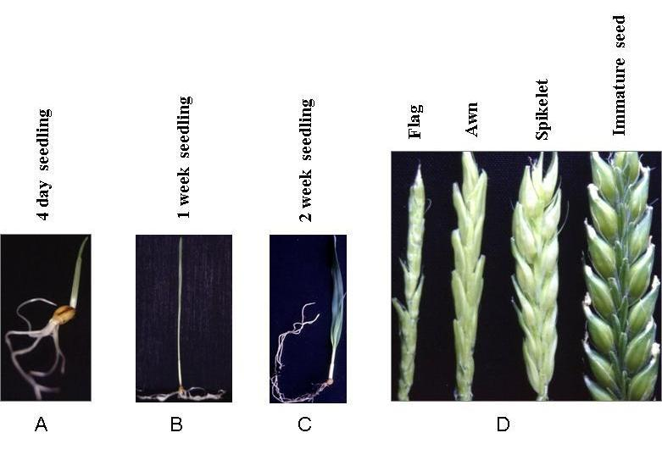

Figure 1. Development and appearance of cultivar Chebec at various sample collection stages. A, B, and C: seedlings at vegetative stage. D: inflorescence parts at floral stage of indoor plants.
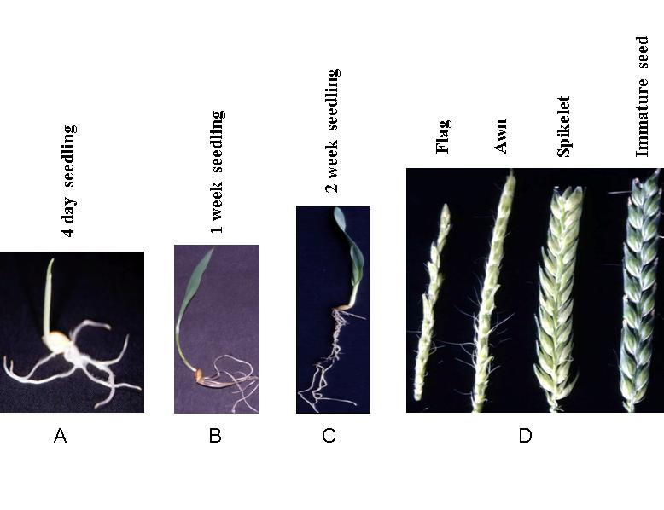
Figure 2. Development and appearance of cultivar Harrington at various sample collection stages. A, B, and C: seedlings at vegetative stage. D: inflorescence parts at floral stage of indoor plants.

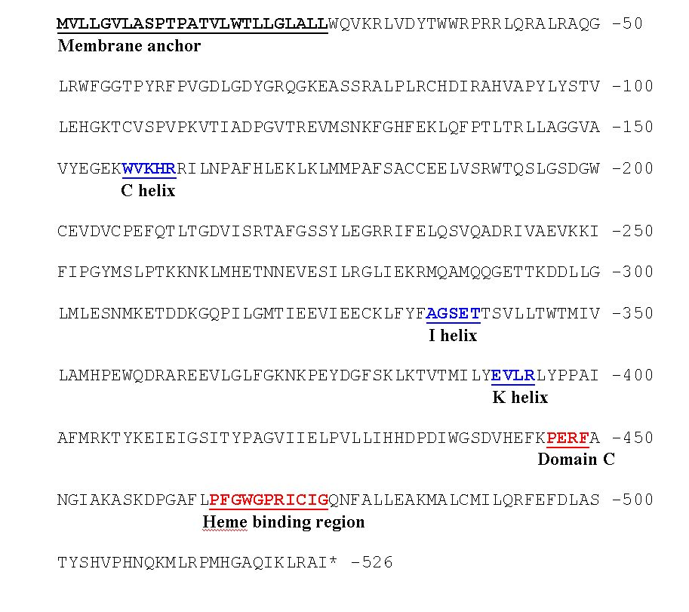
Figure 3. Deduced amino acid sequence of CYP72A39 is shown in capital letters. Motifs and domains are underlined. Stop codon is indicated by asterisk (*).

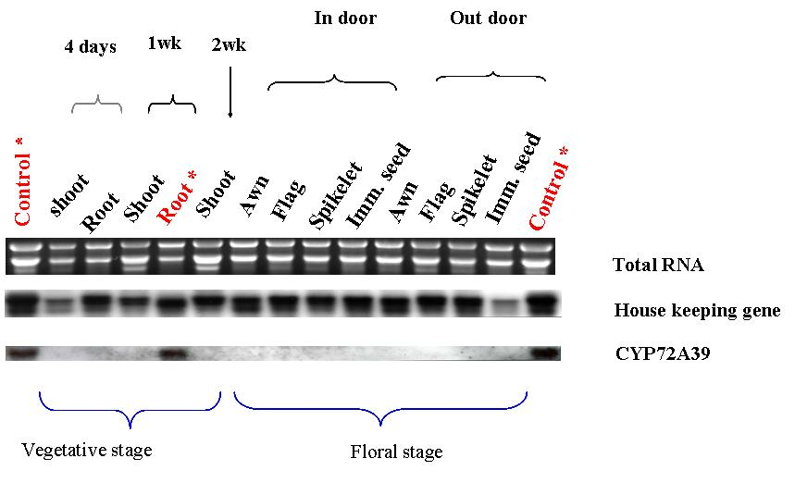
Figure 4. Expression patterns of CYP72A39 in cultivar Chebec by Northern blot analysis. Asterisk (*) indicates expressed tissues.
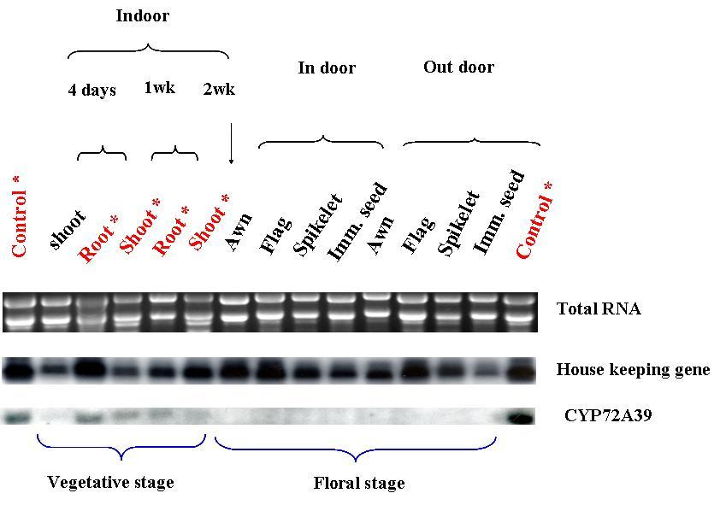
Figure 5. Expression patterns of CYP72A39 in cultivar Harrington by Northern blot analysis. Asterisk (*) indicates expressed tissues.

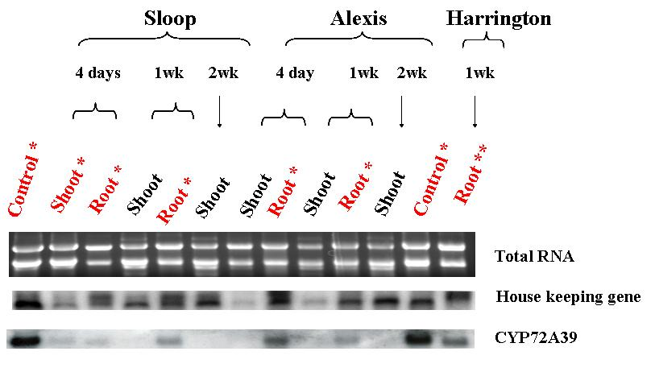

Figure 6. Gene expression patterns of CYP72A39 in cultivars Sloop and Alexis by Northern blot analysis. Asterisk (*) indicates expressed tissues. Double asterisk (**) indicates expressed tissue of 1 week old seedling root of Harrington (as shown in Figure 4) used as an extra internal control.
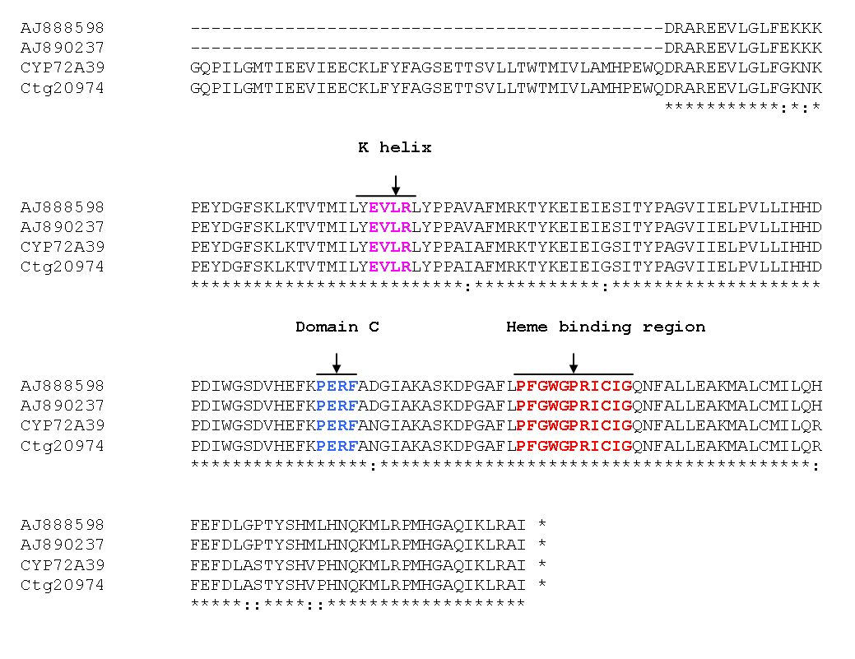
Figure 7. Alignment of CYP72A39 and the three EST sequences (barley contig 20974, wheat AJ888598 and AJ890237). Motifs are indicated by arrows. Mismatched sequences are indicated in colon (:). Stop codon is indicated by asterisk (*).

