Barley Genetics Newsletter (2005) 35:1-2

Maize Transposable Elements and Barley:
A New Population for Genetic Research

Jaswinder Singh, Shibo Zhangand Peggy G. Lemaux, Univ. of California, Berkeley, CA
Phil Bregitzer, Anne K. Sturbaum, and Vince Edwards, USDA-ARS, Aberdeen, ID
Pat M. Hayes, Lol D. Cooper, and Luis Marquez-Cedillo, Oregon St. Univ., Corvallis, OR
Vickie Carollo, USDA-ARS, Berkeley, CA

The development of a gene-tagging system for barley was initiated shortly after Wan and Lemaux (1994) demonstrated the feasibility of introducing genes into barley via particle bombardment. Tagging genes via transposon insertions in barley is an attractive proposition: barley, a true diploid, lends itself to genetic studies, and its close homology to other members of Triticeae make the results of such studies broadly applicable. By developing a resource comprised of many lines, each line containing a transposable element in a different genomic position, we hope to facilitate saturation mutagenesis, based on the propensity of Ds to insert into nearby genes via the phenomenon of local, cis-transposition.

The system developed in barley relies on two parts of the maize Ac/Ds system, introduced into separate plants via particle bombardment into the cultivar Golden Promise. One component is a transposition-competent Ds-bordered, ubiquitin-driven bar gene (Ds-bar); the other, a transposition-incompetent Ac transposase (AcTpase) gene driven by either the ubiquitin or the native Ac promoter. Ds-bar is activated to transpose by crossing the two plants. Expression of bar enables simple herbicide-based screening with glufosinate-ammonium(Bregitzer and Tonks, 2003). McElroy et al. (1997) and Koprek et al. (2000) showed transient and stable functionality, respectively, of this system in barley via AcTpase-mediated transpositon of Ds-bar cassettes. Lines with single, unique Ds-bar insertions (TNPs) were identified and mapped using a sequence-based approach by Cooper et al. (2004). Furthermore, this approach provided additional evidence that the Ac/Ds system functions in barley as it does in maize: there was a higher frequency of cis- versus trans-transposition; transposition occurred primarily to coding regions (frequently with homology to known genes); and transposition was accompanied by an 8 bp duplication of the sequence into which insertion occurred. Also typical of this system in its native maize, the terminal inverted repeat (TIR) of the Ds element was in some cases altered and such changes to the TIR appear to interfere with further transposition (Singh et al., unpublished).

Cooper et al. (2004) present detailed information on the first 19 TNP lines for which unique map locations have been verified (Figure 1). Since that publication, additional TNP lines with unique insertions have been identified and mapped. All TNP lines are in the Golden Promise background, although efforts are underway to develop similar populations in Oregon Wolfe Barley (Singh et al., unpublished). Information on all TNP lines, including information about flanking genomic regions, status of TIRs, Morex BAC clone hybridization data, and forms to enable distribution of TNP and AcTpase lines to other researchers can be found at the Transposon-mediated Functional Genomics in Barley website http://wheat.pw.usda.gov/BarleyTNP.

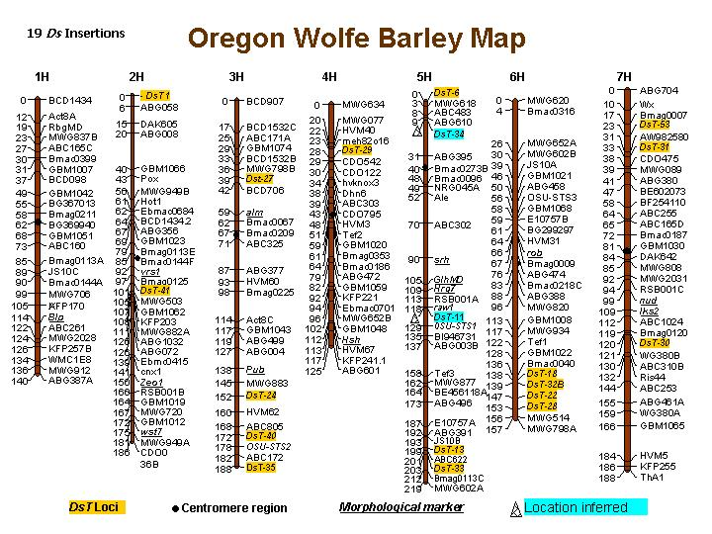
Figure 1. Map locations of transposed Ds-bar elements (DsT's) in the Golden Promise TNP lines based on mapping in Oregon Wolfe Barley or other (denoted as "inferred") mapping populations. For additional detailed information, see Cooper et al., 2004 and http://wheat.pw.usda.gov/BarleyTNP.

References:

Bregitzer, P., and D. Tonks. 2003. Inheritance and expression of transgenes in barley. Crop Sci. 43:4-12.
Cooper, L.D., L. Marquez-Cedillo, J. Singh. A.K. Sturbaum, S. Zhang, V. Edwards, K. Johnson, A. Kleinhofs, S. Rangel, V. Carollo, P. Bregitzer, P.G. Lemaux, and P.M. Hayes. 2004. Mapping Ds insertions in barley using a sequence-based approach. Mol. Gen. Genomics 272:181-193.
Koprek, T., D. McElroy, J. Louwerse, R. Williams-Carrier, and P.G. Lemaux. 2000. An efficient method for dispersing Ds elements in the barley genome as a tool for determining gene function. Plant J. 24:253-263.
McElroy, D., J.D. Louwerse, S.M. McElroy and P.G. Lemaux. 1997. Development of a simple transient assay for Ac-Ds activity in cells of intact barley tissue . Plant J. 11:157-165.
Wan, Y. and Lemaux, P.G. 1994. Generation of large numbers of independently transformed fertile barley plants. Plant Physiol. 104:37-48.

